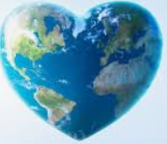
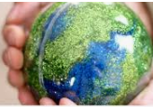
Science Week # 3 Earth Day
Earth day is an annual event celebrated in more than 193 countries around the world on April 22nd to demonstrate support for environmental protection.
Part A- Click on the link below to listen to scientists from all over the world share what they love most about our planet.

https://www.express.co.uk/news/science/1271511/Earth-Day-2020-what-is-Earth-Day-why-celebrate-50-anniversary

Part B – Select one of the options below:

Option #1- Write a short paragraph explaining what you love most about planet Earth and how we can help protect it.

Option #2 Try the Science Connections Activity: “Oil Slick Clean Up!”

Fill a clear plastic container a little over halfway with water and add a few drops of cooking oil. Try mixing them together. We know that oil and water don’t mix. Why is this? Write down your findings on paper.

Then, try this:
Look around your home for different absorbent items (coffee filters, sponges, cotton scraps, paper towel, etc. Try placing various items (one at a time) into the container of water, moving it around to soak up the spill.

Try containing the oil by blocking off a small area with several pieces of the absorbent material. Can you make a square around the spill, without any oil escaping?

Try this project again using one of the other absorbents. (You may need to add more oil to the water to create more slicks.)

Share what you learned:
- What item worked the best?
- How could your findings be used in the real world?

